Jyoti Moni Deka 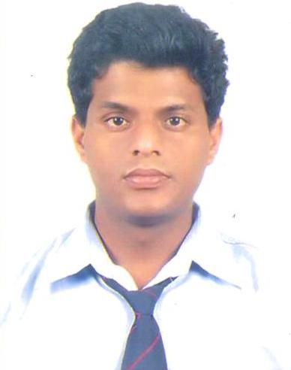
Objective:
To be a perfect engineer and work in an esteemed organization where I can exploit my full potential for the mutual benefit of organization and self.

Educational Qualification:

Aug’09-July’13 : B Tech in Electrical and Electronics Engineering with 61% from Tula’s institute Dehradun( Uttarakhand Technical University).

Jul-May (2008) : Higher Secondary
Mangaldai Ranjit Sarma Academy(AHSEC) 55%

July-May(2006) : Matriculation
Mangaldai Govt. H.S. School(SEBA) 57%

Industrial Training:

- Undergone 4 weeks training at A.P.D.C.L,Assam(2012).

Project Undergone:

Project Title: “water level Controller Cum Motor Protector”
Regarding: Minor project.

“Electronic circuit breaker”
Regarding: Major Project.

Technical Skill:

- Basic electrical, Basic electronics.
- M.S office.
- Industrial Automation(PLC,SCADA,HMI,AUTOCAD)

Extra/co-curricular Activities:
- Undergone 10days workshop of Embedded Systems And Related Applications from Gauhati University(2012).

- Undergone 2days workshop of Ethical Hacking & Information Security from Kyrion Digital Securities(2011).

Personal Details:

- Marital Status : Unmarried
- Father’s name : Ratneswar Deka.
- Correspondence Add : C/O-Ratneswar Deka,
- Baruapara,W/N-4,P.O-Mangaldai,
PIN-784125,Darrang,Assam.
- Date of Birth : 26th ,July, 1990.
- Sex : Male
- Languages known : Hindi, English, Assamese.
- Email : jyotimonideka@gmail.com
- Contact No. : 07503136924

